

|  |
| --- |
| PowerShell Scripts for Crestron Control  Processors & Touch Panels  March 2021 |
| Confidential |

# Document History

|  |  |  |  |
| --- | --- | --- | --- |
| Date | Document Version | Author | Description |
| 2021-03-23 | 01.00 | Jonathan Arndt | Initial Draft |

# Contents

Document History 2

Contents 3

Synopsis 5

Purpose 5

Assumptions 5

Required Tools 5

Software Versions 6

Firmware Requirements 7

Pre-Script Execution Guide 8

Step 1) Setup an Execution Policy 8

Step 2) Import Crestron PowerShell Module (if running script attended) 8

Step 3) Create initial folder structure 8

Script Execution > Update Firmware 9

How to Connect to a Device 9

How to adjust the Ethernet settings on a Control Processor 10

How to Install PepperDash Software on a Control Processor 11

How to Install PepperDash Graphics (iPad or X-Web) on a Control Processor 12

Script Execution > Enable Authentication 14

How to Connect to a Device 14

Script Execution > Unattended 15

How to Connect to a Device 15

Notices 16

Notice of Ownership and Copyright 16

The material in which this notice appears is the property of PepperDash Technology Corporation, which claims copyright under the laws of the United States of America in the entire body of material and in all parts thereof, regardless of the use to which it is being put. Any use, in whole or in part, of this material by another party without the express written permission of PepperDash Technology Corporation is prohibited. PepperDash Technology Corporation reserves all rights under applicable laws. 16

Notice of Confidentiality 16

The material in which this notice appears is confidential to PepperDash Technology Corporation. If you have been provided a copy of this material, it is with the understanding that you will not share it with others without the express written consent of PepperDash Technology Corporation. 16

Notice of Trademark and Servicemark 16

# Synopsis

## Purpose

This documentation is written for software, developed by PepperDash, for Crestron controlled systems. The purpose of this document is to provide guidance on executing PowerShell scripts that will connect to Crestron control processors and touch panels performing automated functionality detailed in this document.

## Assumptions

It is assumed that the user of this document has the following training and/or expertise:

* Familiarity with Crestron Toolbox software
* Basic understanding of working program and folder structure on Crestron 3-Series processors and TSW touch panels
* Basic understanding of how to use and run Microsoft Windows PowerShell

## Required Tools

* Windows 7 operating system or higher
* Windows PowerShell (32 or 64 bit) or Windows Integrated Scripting Environment (ISE 32 or 64 bit), minimum Windows PowerShell version 3
* Crestron PowerShell Scripting Enterprise Development Kit (EDK)  
  <https://sdkcon78221.crestron.com/downloads/EDK/EDK_Setup_1.0.5.3.exe>
* TCP/IP network connectivity to Crestron control processor or touch panel
* Access to [PepperDash Portal](https://portal.cloud.pepperdash.com/)
* PowerShell script software package from PepperDash (obtained from [PepperDash Portal](https://portal.cloud.pepperdash.com/))

## Software Versions

|  |  |  |
| --- | --- | --- |
| Load file(s) to Crestron control Processor or Touch Panel | Release Version | Release Date |
| PDT.PowerShell.LoadScript.PS1 | v01.00 | 3/23/2021 |

|  |  |  |
| --- | --- | --- |
| Enable Authentication (from default) Script | Release Version | Release Date |
| PDT.PowerShell.Authentication.ps1 | v01.00 | 3/23/2021 |

# Firmware Requirements

The following equipment must be running the required firmware. PepperDash PowerShell scripts assume Crestron equipment is running latest provided device firmware prior to executing scripts.

|  |  |  |  |  |  |
| --- | --- | --- | --- | --- | --- |
| Manufacturer | Model | Device Type | Crestron PUF | Firmware | Release Date |
| Crestron | 3-Series | Processor | N/A | 1.7000.0021 | Jan, 2021 |
| Crestron | TSW | Touch Panel | N/A | 3.000.0014 | Oct, 2020 |

# Pre-Script Execution Guide

## General Disclaimer

All scripts written by PepperDash (and Crestron) require the PowerShell Execution Policy set to ‘remote signed’. This allows provided scripts to be ran on a local machine that were originally created on another machine. See instructions below on how to set the execution policy. Note: If you intend on utilizing PowerShell-5 ISE (Integrated Scripting Environment) for running attended scripts but later wish to utilize some other form of PowerShell command-line for unattended (example: PowerShell 7), you will need to set the execution policy to ‘remote signed’ for both PowerShell-5 and PowerShell-7.

## Step 1) Setup an Execution Policy

1. 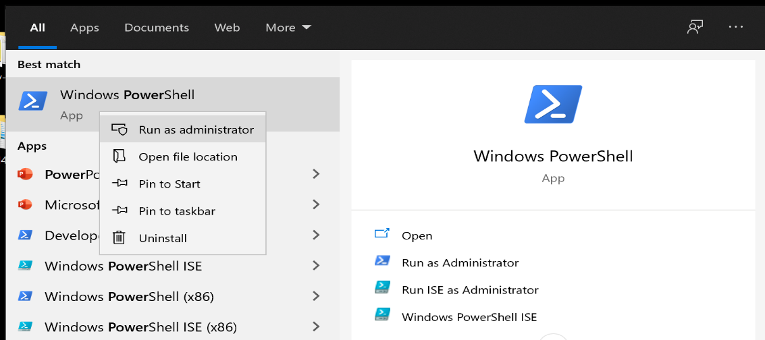Open PowerShell or PowerShell ISE **as an Administrator.**
2. 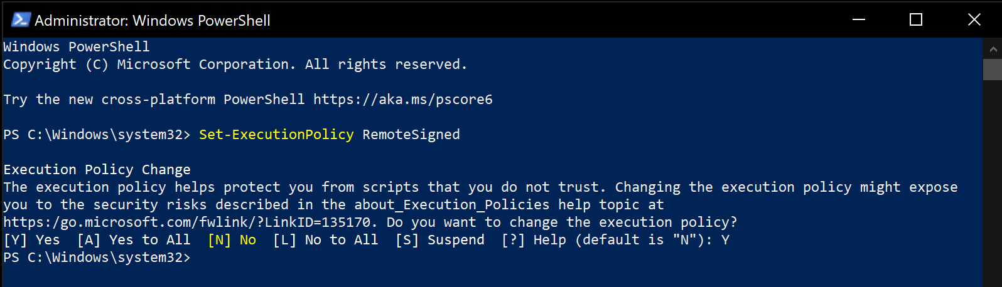Use the following command (cmdlet) to enable running remotely signed scripts (note: all PepperDash scripts utilize Crestron cmdlets which are signed): “**Set-ExecutionPolicy** RemoteSigned”

## Step 2) Create initial folder structure

1. Create a new folder on your desktop for running PepperDash scripts. Call this new folder something easily referenced (typically this folder is called, ‘PepperDash-Scripts’.)
2. Within the ‘PepperDash-Scripts’ folder there should be sub-folder called, ‘Scripts’ where the actual PowerShell scripts reside.
3. If you desire to run a PepperDash script unattended or desire to load files to a Crestron controller, then create another folder within the ‘PepperDash Scripts’ root folder called, ‘Packages’. Running PepperDash scripts unattended requires the use of a JSON formatted address book file with the file extension of *.pda (example: addressBook.pda). The address book file must be Java-Script-Object-Notation formatted or JSON. Example address books will be provided.
4. No need to create the ‘Logs’ folder as this folder and any associated logs will be generated automatically.

## 

# Script Execution > Update Firmware (Attended)

## Update Crestron Control Processor or Touch Panel Firmware (Attended)

1. 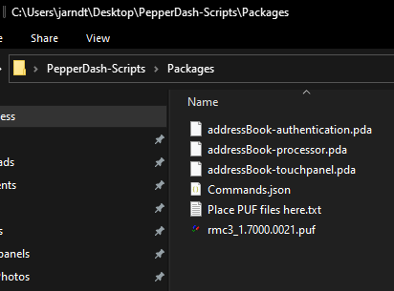Place firmware PUF file in the ‘Packages’ folder.
2. Navigate to provided PowerShell script titled, **‘PDT.PowerShell.LoadScript.PS1**’ (Note: This file should be located in the ‘Scripts’ folder).
3. 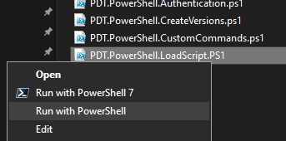Right-click file and select option to ‘Run with PowerShell’. PepperDash recommends running scripts in a PowerShell command console.
4. If script discovers multiple files possible to load to the processor or touch panel the script will query for a choice of files to load.

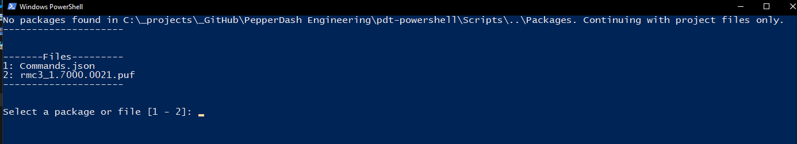

1. Enter a value for the desired file selection. The example above allows for a value of either ‘1’ or ‘2’. *Note: At this prompt you are not able to load multiple files to a Processor or Touch Panel. Should you desire to load multiple files please utilize the separate PowerShell script titled, ‘LoadScipt’ for this purpose.*
2. Provide the ‘device username’ of the processor or touch panel required to connect via SSH. If the device credentials or authentication have not been setup the option to choose the default value of ‘Crestron’ is allowed by hitting enter when prompted.
3. Provide the ‘device password’ of the Processor or touch panel required to connect via SSH. If the device credentials or authentication have not been setup the option to choose the default empty value is allowed by hitting enter when prompted.
4. Provide the device type that files will be loaded to. A value of ‘1’ for Processor or ‘2’ for Touchpanel are the only allowed values.

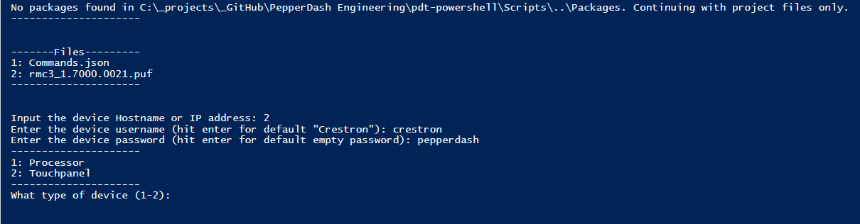

1. The script will prompt asking if the address provided should be added to an existing address book. By default, this value should be ‘N’ for no.

# Script Execution > Enable Authentication

## Execute ‘Authentication’ Script (attended execution)

1. Start Windows PowerShell or PowerShell ISE Administrator rights.
2. 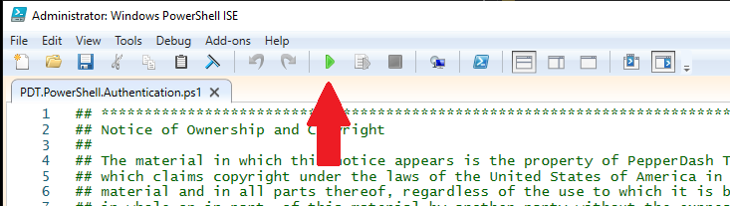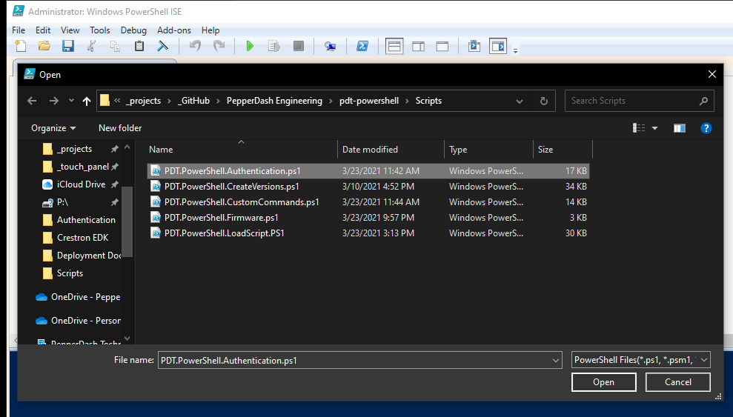If running PowerShell ISE (recommended), open the existing authentication script, and press the ‘Play’ button to execute script.
3. If running PowerShell (non-ISE) from a command line, type in the full path to the authentication script with the prefix: powershell.exe -Command “&. The path must be in single quotes and the end of the command must end with double quotes. Example below:
4. Enter the new username desired for the device after the prompt, “NewUsername”.
5. Enter the new password desired for the device after the prompt, ‘NewPassword”.
6. If using an address book enter the desired address book from the list or type ‘n’ to skip this selection.
7. If using an address book enter the desired address or ‘a’ for all or ‘n’ to skip.  
   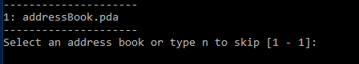
8. If no address book file (*.pda) is discovered by the script (located in the Packages folder) enter the device hostname or IP address.
9. Enter the devices’ current username (note: if authentication has not yet been setup the username is ‘crestron’). Hit enter for default ‘crestron’.
10. Enter the devices’ current password (note: if authentication has not yet been setup the password is blank or empty). Hit enter for default empty password.

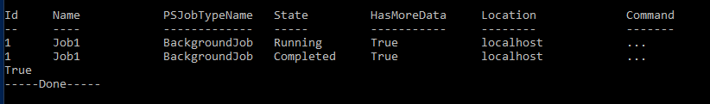Script will provide visual indication of ongoing job running in the background, indication of when the job has completed, and will automatically generate logs showing status of authentication script for each device connected to.

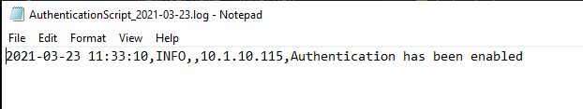

# Script Execution > Unattended

## How to Connect to a Device

1. Connect to the device using Crestron Tool Box > System Info
2. Press the [Pencil] button  in the bottom of the System Info window
3. Select the [TCP] radio button
4. Enter the IP address or hostname (see IP addresses above) into the [IP Address/Hostname] field
5. Press [OK]

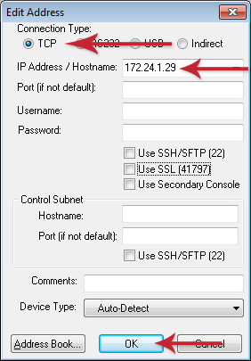

# Notices

## Notice of Ownership and Copyright

## The material in which this notice appears is the property of PepperDash Technology Corporation, which claims copyright under the laws of the United States of America in the entire body of material and in all parts thereof, regardless of the use to which it is being put. Any use, in whole or in part, of this material by another party without the express written permission of PepperDash Technology Corporation is prohibited. PepperDash Technology Corporation reserves all rights under applicable laws.

## Notice of Confidentiality

## The material in which this notice appears is confidential to PepperDash Technology Corporation. If you have been provided a copy of this material, it is with the understanding that you will not share it with others without the express written consent of PepperDash Technology Corporation.

## Notice of Trademark and Servicemark

PepperDash®, Sentegy®, AVUX® and AV360® are the marks of PepperDash Technology Corporation, registered with the U.S. Patent and Trademark Office. PepperDash Portal™, PepperDash Essentials™, and PepperDash Connect™ are the unregistered marks of PepperDash Technology Corporation. Any use, in whole or in part, of these marks by another party without the express written permission of PepperDash Technology Corporation is prohibited.



PepperDash | 800.377.9112 | www.pepperdash.com